1. **Sample view for (Kenderaan Rosak)**

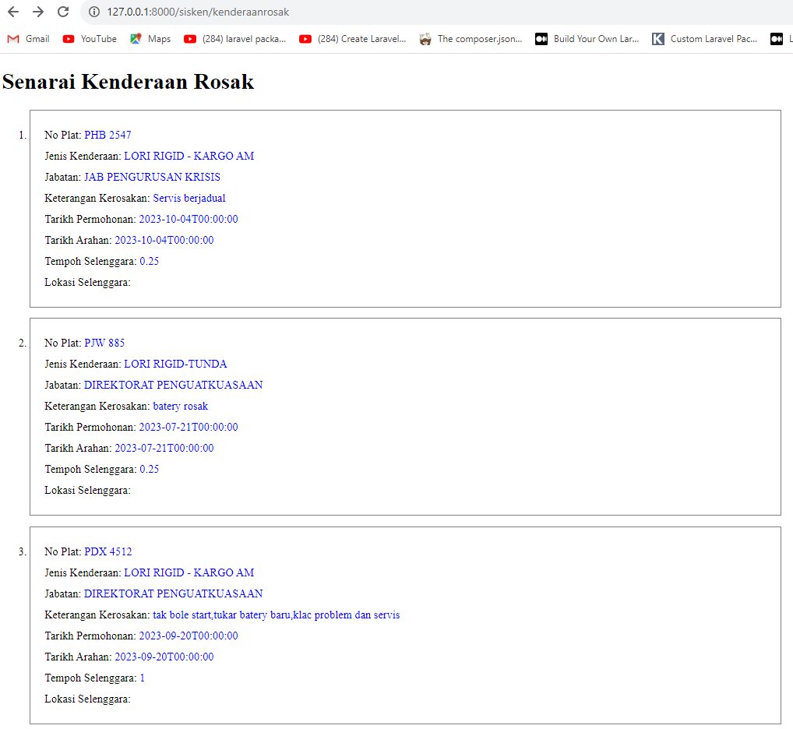

… until 133 record

1. **Sample view for (Kenderaan Servis)**

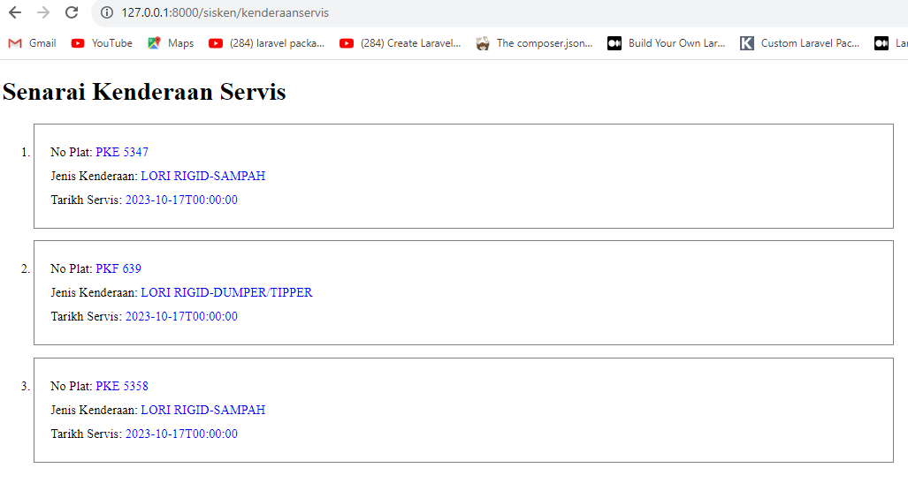

3 records only